一、根据首字母提示或图片写单词（共10分，每空2分）
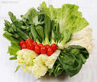
1.Eating a lot of __________ is good for our health.
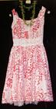
2.This _________ is very beautiful.

3.Give me a piece of _______,please.

4.He likes music very much and he is also good at s___________.

5.We h _________a good time at Lily’s party last night.

二、翻译下列俚语（共8分，每题2分）
1.in hot water：

2.spring for：

3.hit the road：

4.come easily：

三、填空题（共16分，每空2分）
1.The theme of Expo 2010 s “_______________________”, representing the common wish of the whole humankind for a better living in the future urban environment.

2.The earthquake happened in ____________,March 11，2011 and caused_________people to die.Quake and Tsunami leave wake of destruction across_________.

3.Shenzhen26th_________will be held from August 12th to August 22th in 2011 .The main stadium is located in Longgang District , west of the city , about 15 kilometers from the city center.

4.The Britain is made up of _________ and________.

5.Who’s that speaking？
__________is Lucy speaking.

四、Make PPT（共30分）
Our life becomes better and better，but the environment around us becomes worse and worse，How should we do to protect our environment？
Require：at least four pictures，explain your pictures in English.

五、看图，用英语写作文（共36分）
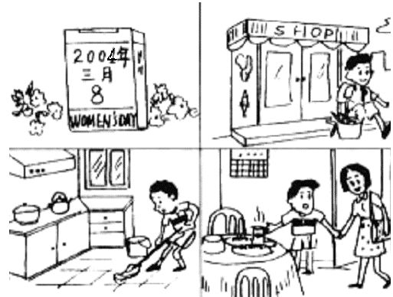
Request：at least 80 words.

